BETTer Project

### Group members

Franco Evett

Anas

Anthony

Romi

Pruthvi

Camron

Felipe

## Learning Objective For Brief

LO1: Plan, manage and track a substantial group activity.

LO2: Take an open-ended problem, collect and analyse relevant information and define and refine the requirements.

LO3: Independently and systematically design, develop and test a piece of software that is data-driven and has non-trivial functionality.

LO4: Compare and evaluate alternative problem solutions according to given criteria including from a technical perspective.

LO5: Effectively present, communicate and market ideas and solutions to different audiences.

LO6: Understand and apply the principles of professional and ethical behaviour in a group context.

LO7: Reflect and learn from the group project experience.

## 

## Group Meeting Agenda 21/11/2019

### Project Discussion

1. Make sure everybody is on the same page and knows what the project is
2. Collect ideas on the project
3. Discuss requirements
4. Interface Discussion
5. GUI Discussion
6. Discussion on project timescale estimation

### Communication

1. Resend the discord link because it expired
2. Find a day each week to have a group meeting
3. Who lives on campus/travel times
4. Record each group meetings content for the project writeup
5. Set names on discord and WhatsApp to actual names
6. Discuss GitHub project management

### Team Skills Discussion

1. How many people in the group can program
2. Who is good a GUI designer

### Work For Next Week

1. Requirements Specification - Romi
2. Risk analysis - Camron
3. GUI Design - Anthony
4. Entity Relationship Diagram - Anas
5. Use Case Expansion - Franco
6. Data Scraping - Pruthvi
7. Document Planning ?
8. Interface ?

### 

### Agenda Accomplishments - 21/11/2019

1. Create a GItHub repository
2. Add everyone to GitHub repository
3. Organised a new meeting time each week
4. Discussed the project concept
5. Discussing the project timescale
6. Drawn basic GUI design for the project
7. Assigned tasks to everyone (Design Phase)

### Requirements:

The below data is an outline that needs to be written up in a pull page report. An explanation describing the system and what features it will have followed by a bullet point list of features.

User Requirements:

1. Easy access to timetable
2. Notifications
3. Settings
4. Create Events
5. Travel Time

System Requirements:

1. Database
2. Notification System
3. User Account Information + Login System
4. Lab Setup - Select Your Labs
5. Create Events
6. Easy Main Display

## Group Meeting Agenda 26/11/2019

### Assigned Work Discussion

1. Last meeting (very close to this meeting)
2. Work Needs to be done
3. Some members have done work but not uploaded it

### Communication

1. Work Needs to be Uploaded to Github to show weekly progression and allow for group review

### Work For Next Week

1. Requirements Specification - Romi
2. Risk analysis - Camron
3. GUI Design - Anthony
4. Entity Relationship Diagram - Anas
5. Use Case Expansion - Franco
6. Data Scraping - Pruthvi

This has been uploaded to Github its the basic process of how the app will work. Use this to base all of the entities required the GUI pages needed and so forth.

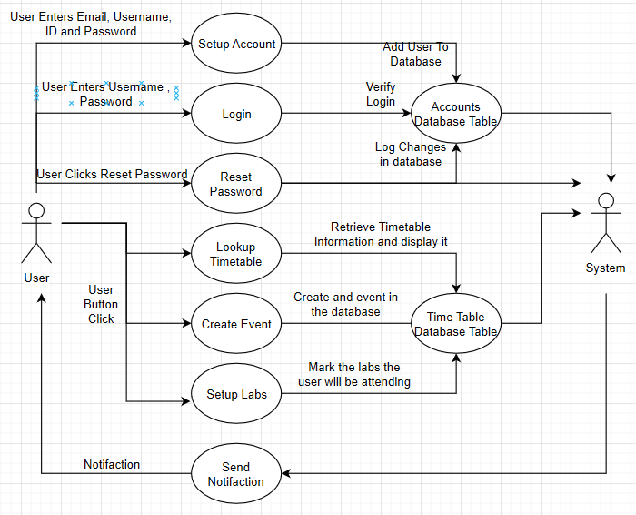

### Agenda Accomplishments - 26/11/2019